**Department of Electronic and Telecommunication Engineering**

University of Moratuwa Faculty of Engineering

Electronic Design Realization EN2160

**Pick and Place Robot Arm**

Design of the Prototype Report

Group members:

210625H – SURENDRA SAJE

210668P – VIDMAL HVP

210490L – PRABODHA KPKA

210418C – NAYANTHRA JNP

# **1. User Requirements**

## **Project Objective:**

To automate the assembly of customized H-bridge with a Metal Ring and 6 Transistors accurately with a robot arm, enhancing the efficiency and precision of the manufacturing process.

This project focuses on two key subtasks:

1. **Assembling TRANSISTORs, washers, and rivets into a single unit:** This delicate process requires precise handling and placement, making automation crucial for accuracy and efficiency.
2. **Precise placement and rotation of the metal ring for the pivoting process:** The metal ring serves a critical function, and its accurate positioning and rotation are essential for optimal performance.

This *Design of the Prototype Report* delves specifically into the crucial subtask of **Precise Metal Ring Placement and Rotation for The Pivoting Process**.

### Background:

H-bridges are fundamental components used in electronic circuits to control motors and actuators, allowing for direction change. The precise placement and rotation of the metal ring for the pivoting process are essential for the functionality and performance of the final product. Our goal is to design a pick-and-place robot arm system that can handle this delicate task with accuracy and efficiency.

### Challenges Addressed:

* **Consistency and Reliability:** Manual assembly processes can introduce variability and errors, leading to inconsistent product quality. By automating these tasks, the project aims to standardize assembly steps, ensuring every H-bridge is built to the same high standards.
* **Precision Requirements:** The assembly of H-bridges requires placing metal rings within tight tolerances and precise orientations. Human operators may struggle to consistently meet these exacting standards, especially over long periods or at high production volumes. Automation through a robot arm equipped with high-precision components and feedback systems can achieve and maintain these strict requirements.
* **Efficiency and Throughput:** Increasing the speed of assembly without sacrificing quality can significantly enhance production rates. An automated system designed for rapid picking, placing, and rotating of components can operate continuously, reducing the time required to assemble each H-bridge and thus increasing overall throughput.
* **Workforce Optimization:** Automating repetitive and precision-critical tasks allows the human workforce to focus on more complex, creative, or strategic tasks. This shift can lead to better job satisfaction, reduced risk of repetitive strain injuries, and more versatile use of human skills.

### Expected Outcomes:

* **Higher Quality Products:** By ensuring each metal ring is placed and rotated with high precision, the automation project aims to produce H-bridges that are consistently reliable and performant, thereby reducing failure rates and enhancing the reputation of the manufacturing firm.
* **Increased Production Capacity:** Automation allows for a significant increase in the number of H-bridges assembled per hour, supporting scalability and the ability to meet growing market demands without proportional increases in labor costs.
* **Reduced Operational Costs:** While the initial investment in automation technology might be significant, the long-term benefits include reduced labor costs, fewer errors and reworks, and lower material wastage, all contributing to a more cost-effective manufacturing process.

## **Requirements:**

**Accuracy** - This level of precision is crucial for the proper functioning of the H-bridge, as even minor deviations can lead to suboptimal performance or failure of the device. The requirement demands high-resolution motion control systems and feedback mechanisms to achieve and maintain this level of accuracy.

**Speed** - Speed is essential for industrial efficiency and productivity. This requirement ensures that automation does not become a bottleneck in the manufacturing process. It involves optimizing the robot's movements and the software algorithms that control it.

**Payload** - The robot arm must be designed to handle the specific weight of the metal rings without compromising speed or accuracy. This involves selecting the right motors, gears, and materials for the robot arm to handle the expected load.

**Integration** - **Must be easily integrated into existing assembly lines without extensive modifications.** The design should consider the existing layout and processes of the manufacturing line. It implies modular design, compatibility with current equipment, and possibly customizable software interfaces to communicate with existing systems.

**User Interface** - **Intuitive user interface for programming and operation by technical personnel.** An easy-to-use interface is critical for the adoption and efficient use of the robot arm. It should allow users to program the robot, adjust, and troubleshoot issues with minimal training. This might include graphical programming environments, presets for common tasks, and clear diagnostic information.

**Maintenance** - **Low maintenance requirements with easy access to replaceable parts.** To ensure the robot arm remains operational without significant downtime, it must be designed for durability and ease of maintenance. This means using high-quality, easily replaceable parts and designing the arm in a way that makes these parts accessible for repairs or replacements. Maintenance software tools should provide predictive maintenance alerts, guided troubleshooting, and detailed logs.

**2. Conceptual Designs**

For the pick and place robot arm aimed at precise metal ring placement and rotation for the pivoting process, we developed four conceptual designs, based on three key principles: precision, flexibility, and efficiency; each offering unique approaches to address the project requirements.

### Design – 01 – Surendra SAJE

Figure 1 - Design Sketch 01 by Surendra SAJE

This design features a robotic arm system with 3 degrees of freedom (3DOF) and rotational fingers. It utilizes a conveyor belt to bring the metal ring, along with the assembled transistors, washers, and rivets, to the robot arm for pick-up and placement. The arm is capable of freely moving to execute these tasks.

Figure 2 - Functional Block Diagram for design 01

**Reasons to Refuse Sketch 1:**

* **Complexity:** Incorporating a conveyor belt adds complexity to the system, potentially leading to synchronization issues and maintenance challenges.
* **Practicality Concerns:** Maintenance and reliability issues associated with conveyor systems may reduce practicality in real-world applications.
* **Integration Challenges:** Coordinating the robotic arm with the conveyor belt requires additional mechanisms and may pose integration challenges.

### A drawing of a room Description automatically generatedDesign – 02 – Nayanthara JNP

Figure 3 - Design Sketch 02 by Nayanthara JNP

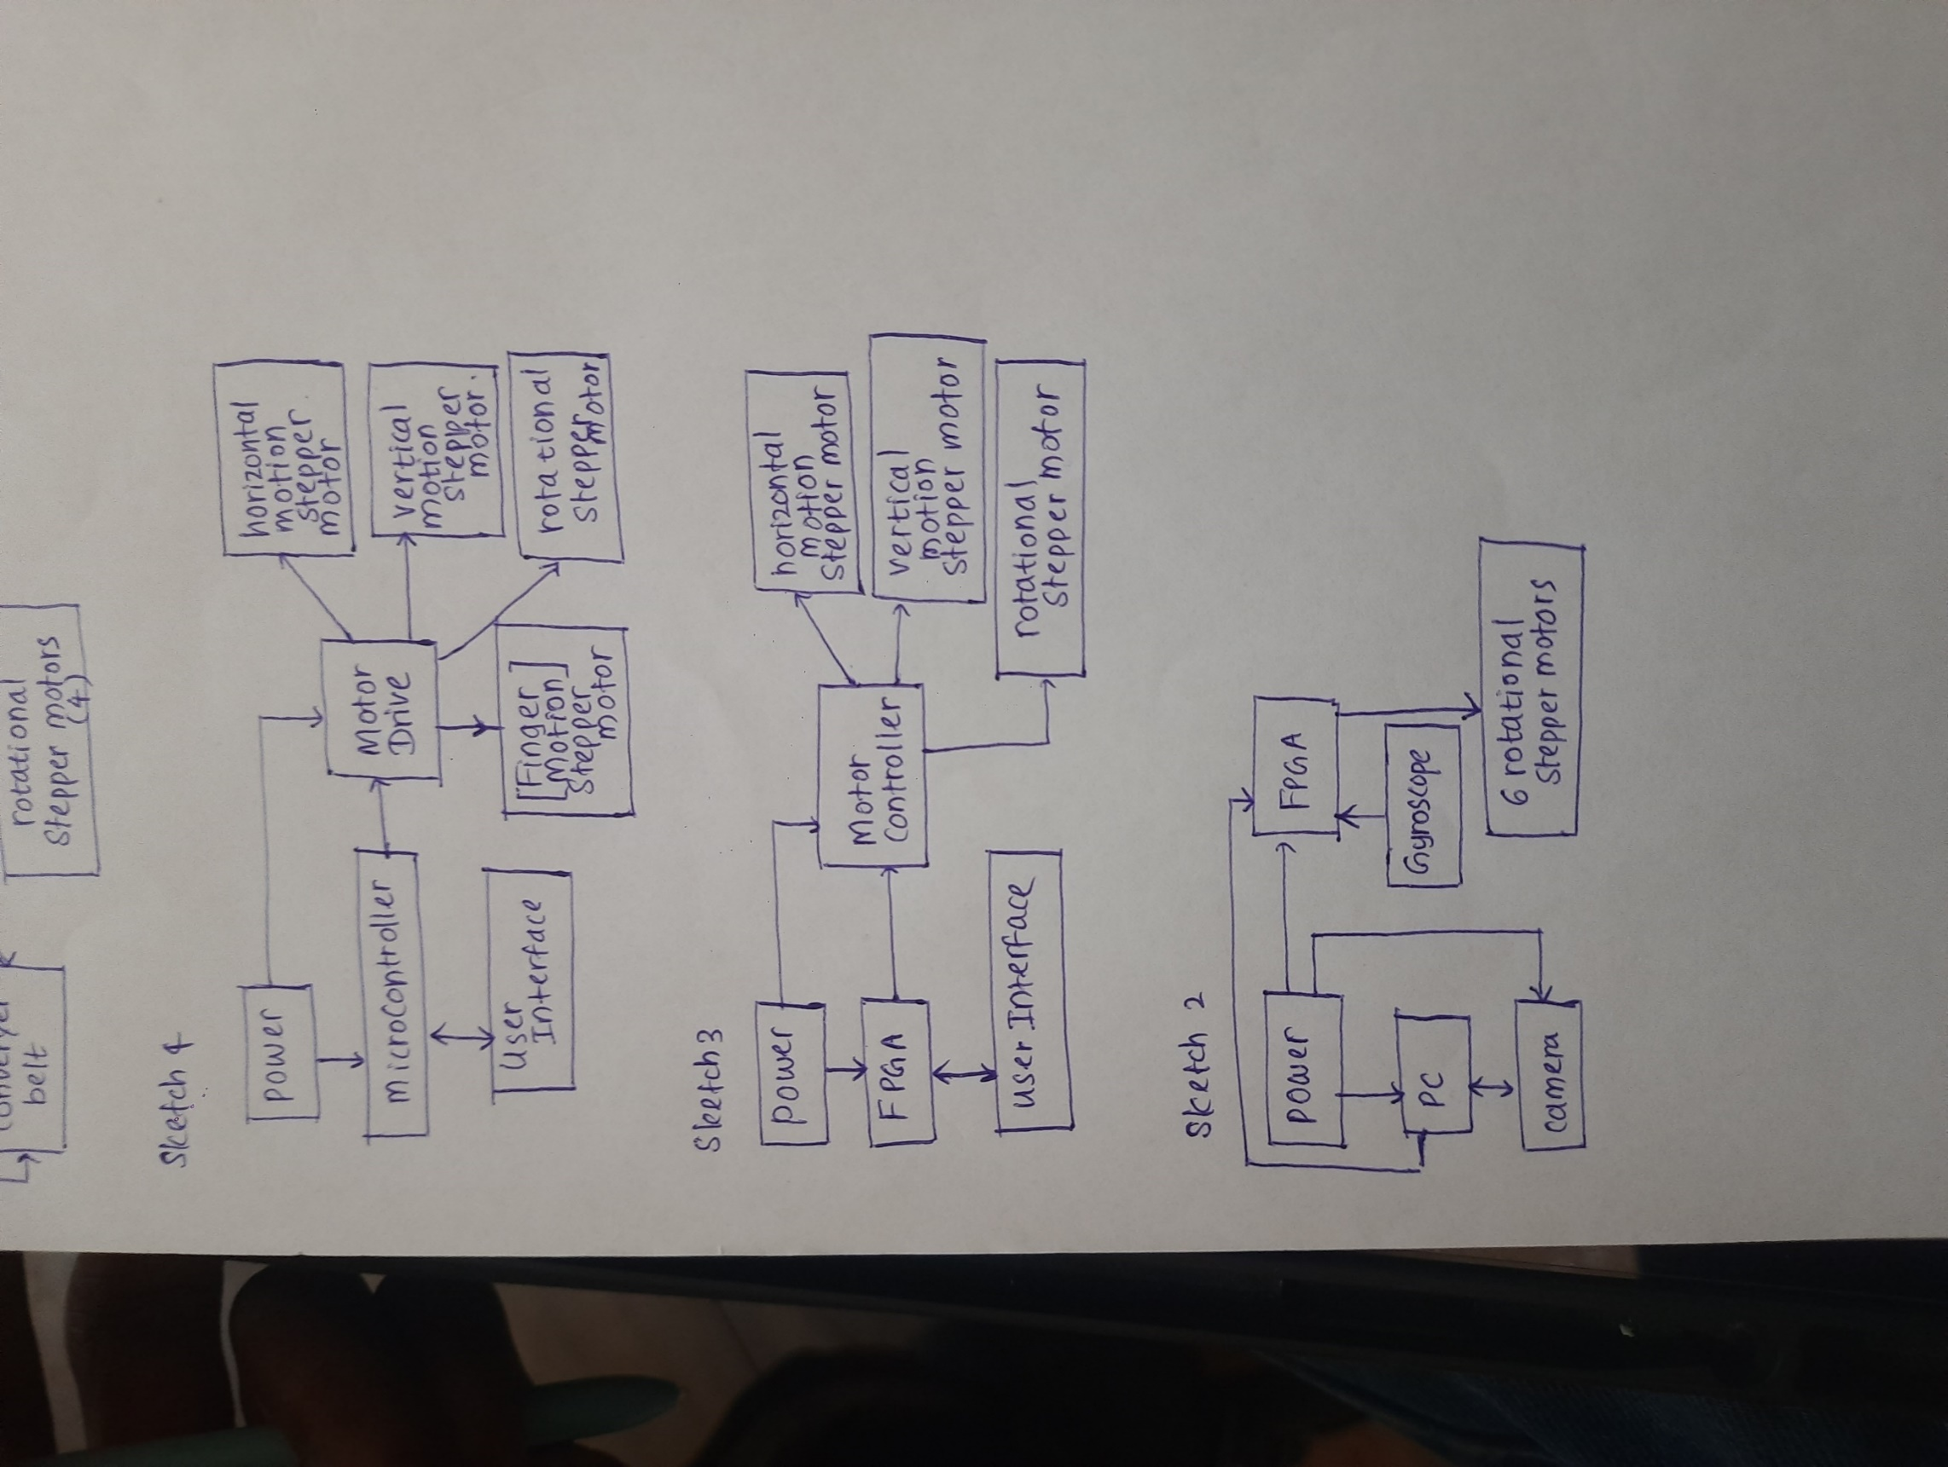Like Sketch 1, this design features an articulated robotic arm with multiple revolute joints for enhanced flexibility and maneuverability. Instead of using a conveyor belt, it incorporates a movable and rotatable finger to rotate the metal ring.

Figure 4 - Functional Block Diagram for design 02

**Reasons to Refuse Sketch 2:**

* **Complexity:** The articulated arm design introduces complexity with multiple revolute joints and additional moving parts.
* **Maintenance Risks:** Increased mechanical complexity may lead to higher maintenance requirements and potential reliability issues.
* **Limited Practicality:** Reliability concerns and maintenance requirements may reduce the practicalityof the design for industrial applications.

### Design – 03 – Vidmal HVP

This design utilizes stepper motors for motion control along the X and Y axes, as well as rotation. It features simplicity in design with three stepper motors for precise motion control.

Figure 5 - Design Sketch 03 by Vidmal HVP

Figure 6 - Functional Block Diagram for design 03

**Reasons to Refuse Sketch 3:**

* **Flexibility Limitations:** Stepper motors may limit the flexibility of the robotic arm compared to designs using servo motors or other actuators.
* **Smoothness of Movement:** Stepper motors may not provide as smooth and continuous motion as other types of actuators, potentially impacting efficiency.
* **Calibration Complexity:** Achieving and maintaining precise calibration with stepper motors may be challenging, leading to calibration complexities and potential performance issues.

Design – 04 – Prabodha KPKA

Figure 7 - Design Sketch 04 by Prabodha KPKA

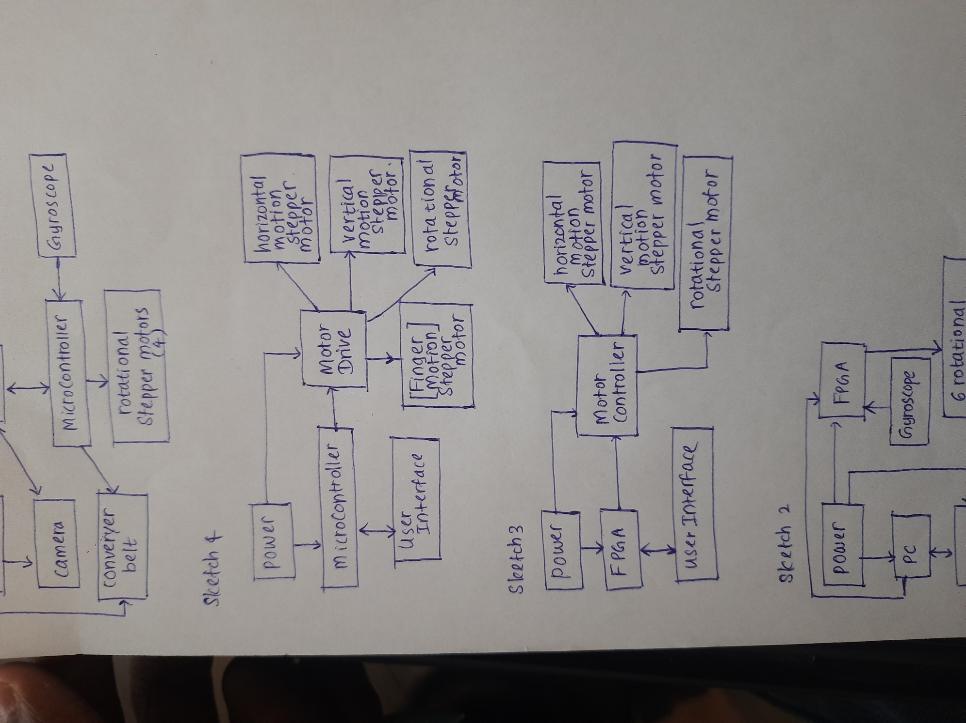

This design features XY motion, arm rotation, and finger motion, powered by four stepper motors. It includes the following components:

Figure 8 - Functional Block Diagram for design 04

**Reasons to Select Sketch 4:**

* **Simplicity with Flexibility:** Sketch 4 offers a balance between simplicity in design and flexibility in functionality.
* **Smooth and Precise Movements:** Utilizing stepper motors ensures smooth and precise movements, crucial for accurate placement and rotation.
* **Adaptability and Integration:** Sketch 4's design allows for greater adaptability to varying assembly tasks and facilitates seamless integration of components.
* **Compatibility with Sub Task One:** Aligns closely with the requirements of Sub Task One, making it the most suitable option for achieving the desired outcome in the H-bridge assembly process.

# **3. Evaluation of the Designs**

To evaluate the conceptual designs, we compared their mechanical parts and functional block diagrams, considering factors such as

* Functionality
* heat dissipation.
* assembly
* serviceability
* simplicity
* durability
* efficiency
* user experience
* feasibility
* cost
* performance
* futureproofing

After careful evaluation of the above factors like below table, we propose to select Robot Arm **Design 4** for our project. This choice is based on several factors:

* **Easy Implementation:** The design offers simplicity and straightforward construction, enabling rapid deployment in production environments.
* **Practicability:** With only linear and rotational movements, this design is practical for the precise placement and rotation of the metal ring.
* **Feasibility:** The robot arm can achieve the required level of precision and accuracy for our application.
* **Smooth Movements:** By controlling motion over the X-axis, Y-axis, and rotation, this design ensures smooth and controlled movements during the assembly process.
* **Adjustable Pivoting Placement:** The robot arm allows for adjustable pivoting placement, accommodating variations in the metal ring's position and orientation.

|  |  |  |  |  |  |
| --- | --- | --- | --- | --- | --- |
| Comparison among concepts. | | | | |  |
| Concept Number | | Concept 1 | Concept 2 | Concept 3 | **Concept 4** |
| Added features | | Conveyor belt | FPGA | Vibration Sensor |  |
| Machine learning | Machine learning | FPGA | **Microcontroller** |
| Vision Camera | Vision Camera | Sliders | **Sliders** |
| Removed features | |  | Jetson Nano | Rotation Arm | **FPGA** |
| Comparison between  Mechanical parts | Functionality | 7 | 7 | 7 | **9** |
| Heat dissipation | 8 | 6 | 7 | **7** |
| Assembly | 8 | 7 | 8 | **9** |
| Serviceability | 7 | 7 | 8 | **8** |
| Simplicity | 5 | 7 | 6 | **8** |
| Durability | 8 | 7 | 8 | **9** |
| Efficiency | 6 | 7 | 8 | **9** |
| Comparison between  Functional block diagram | Functionality | 8 | 7 | 7 | **9** |
| User experience | 8 | 7 | 6 | **8** |
| Feasibility | 7 | 8 | 8 | **9** |
| Cost | 4 | 7 | 8 | **6** |
| Performance | 7 | 6 | 7 | **9** |
| Future proofing | 7 | 6 | 6 | **8** |
| Power | 9 | 8 | 7 | **7** |
| Total | | 99 | 97 | 101 | **117** |

Figure 9 - Robotic Arm Design Evaluation

# **4. Selected Design**

After evaluating the options, **Design 04** is selected for its balance of complexity, cost, efficiency, and ease of integration. Its dual-action gripper design simplifies the mechanical system and minimizes the footprint on the assembly line.

This design offers a balance between simplicity and functionality, providing smooth and precise movements necessary for accurate metal ring placement and rotation. Its adaptability and integration capabilities make it well-suited for industrial applications, aligning closely with the project's objectives and requirements.

Here below well detailed sketch of design 4 diagram included.

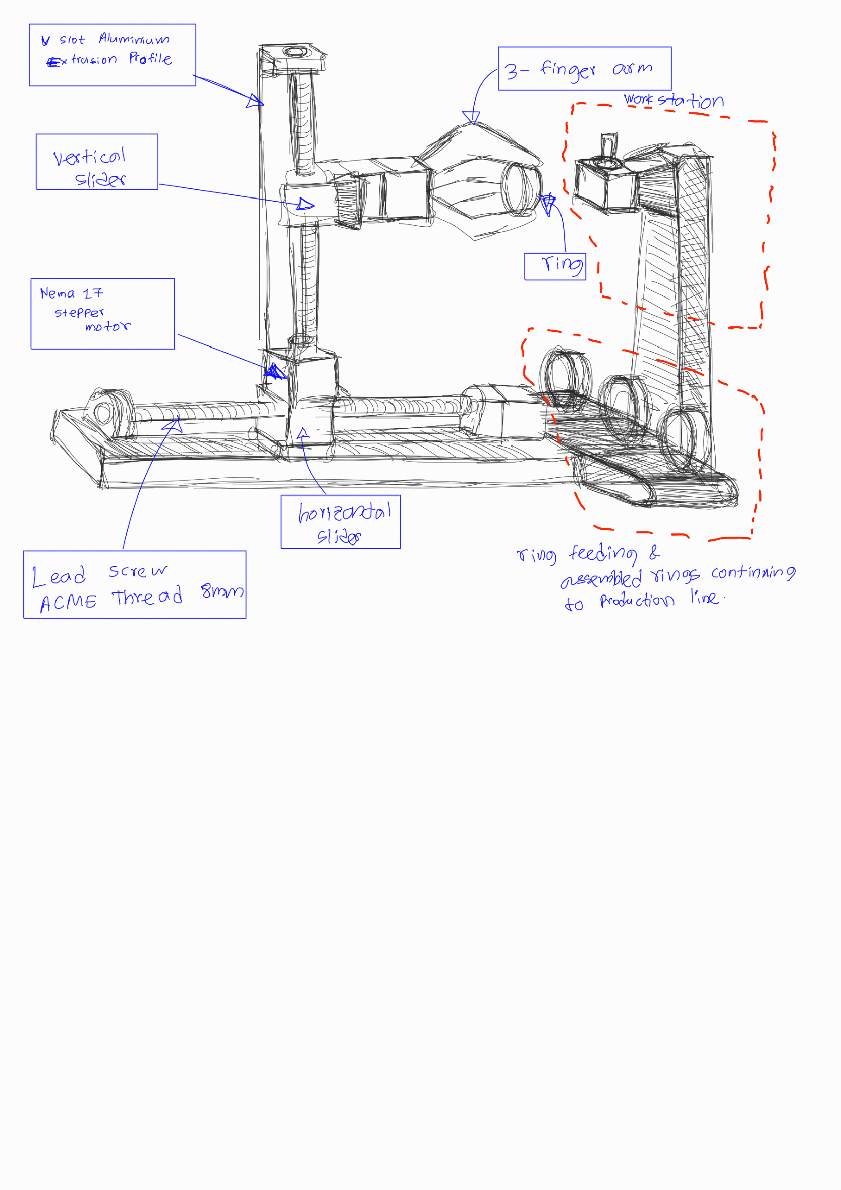

Figure 10 - Selected Design

Figure 11 – Selected Design Block Diagram

# **5. Final SolidWorks design**

## Mechanism

Figure 12 - side view design 04

Gripping Mechanism

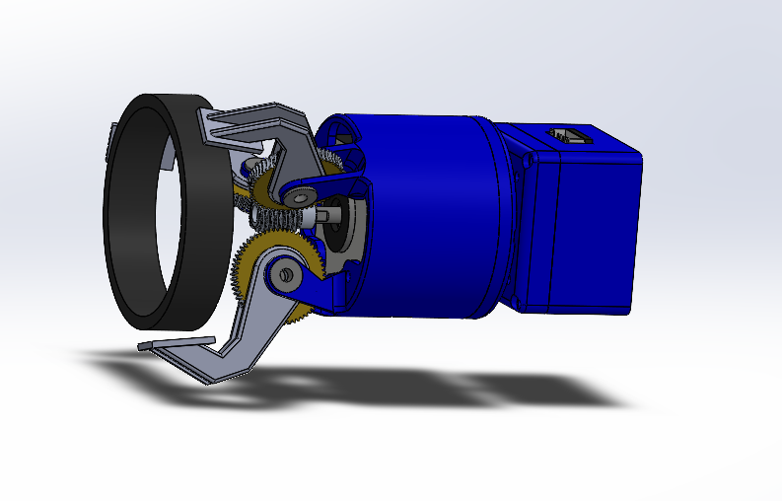

Figure 13 - Gripper arm

## PCB and UI Enclosure

Figure 14 - Enclosure design 3D view

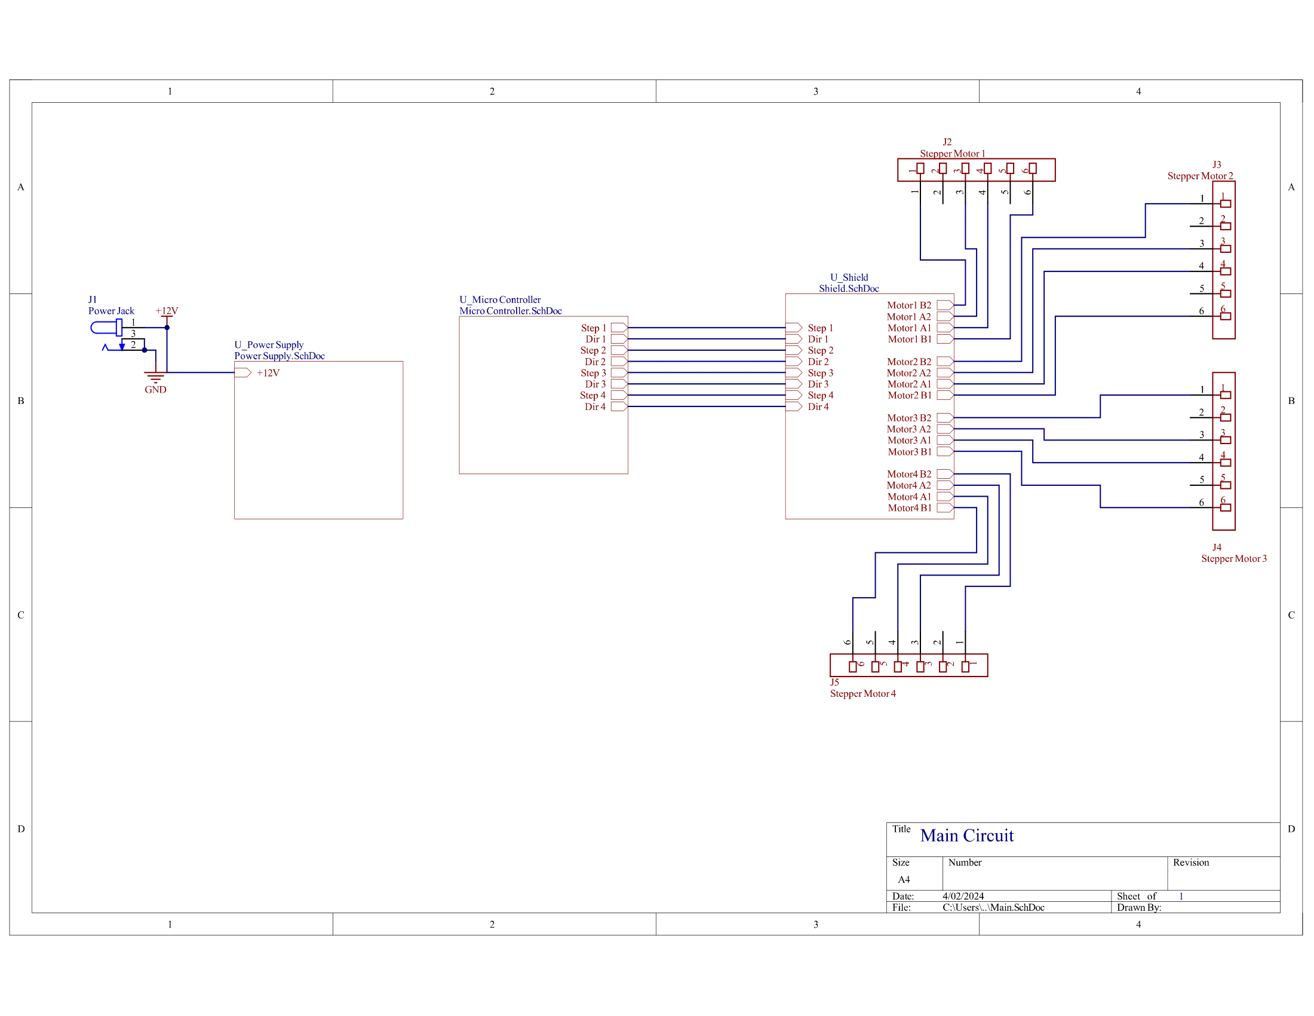**6. Final schematic and PCB design**

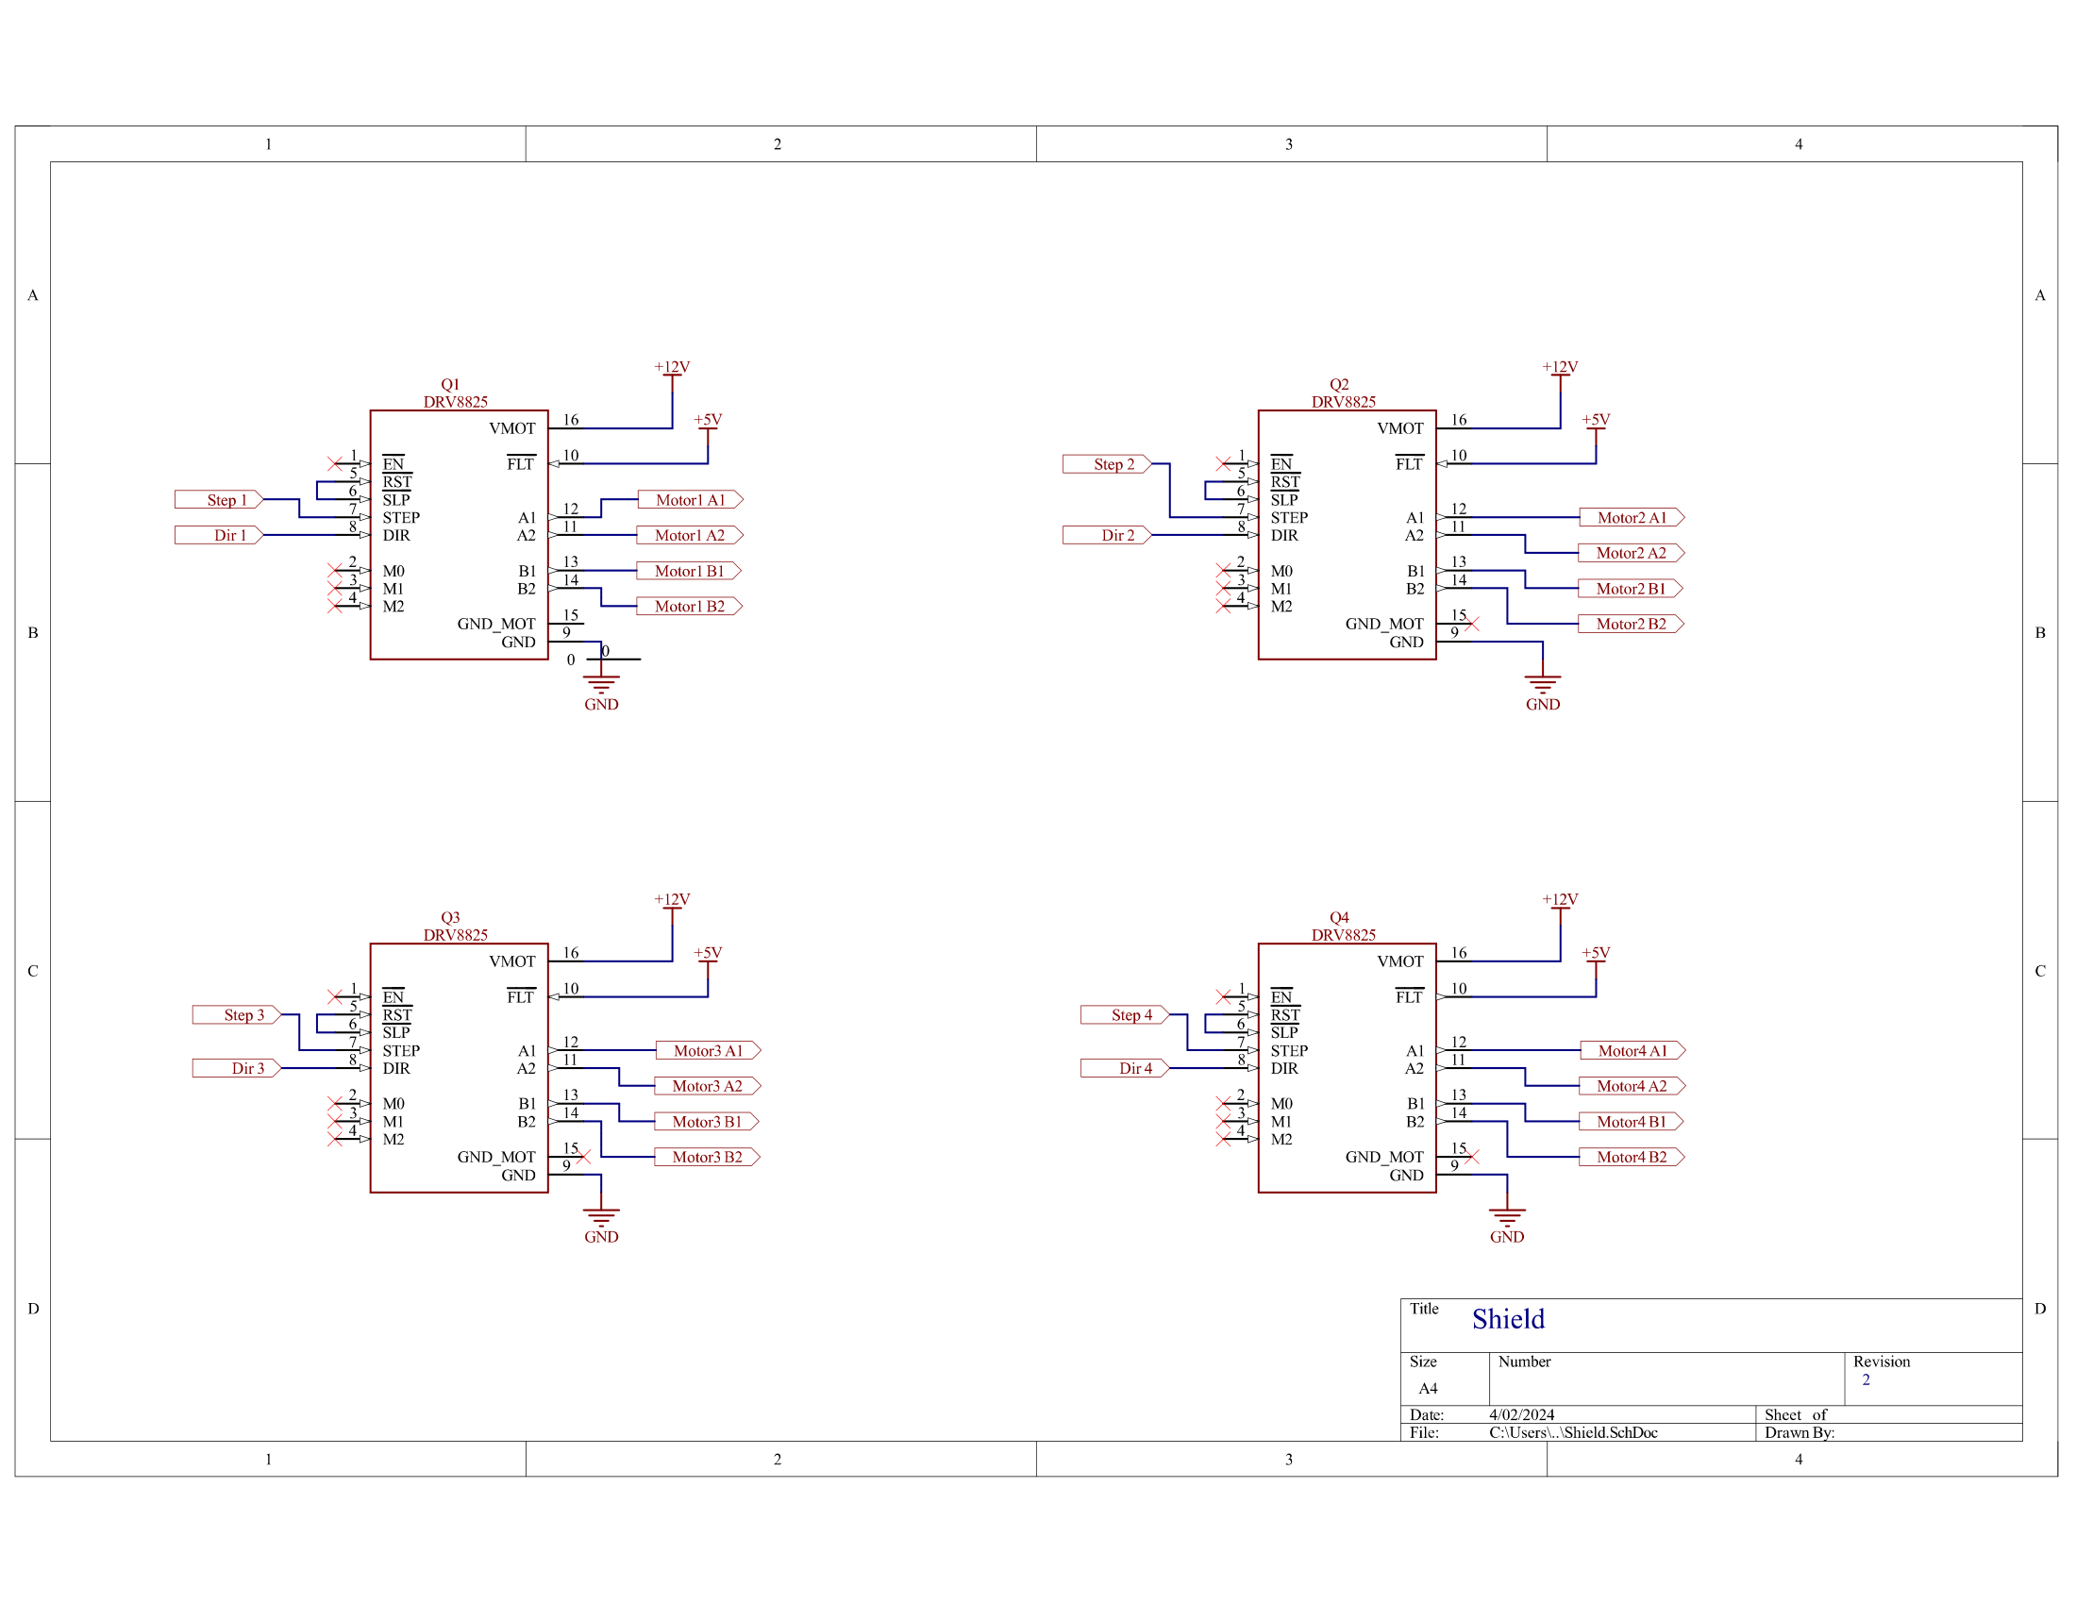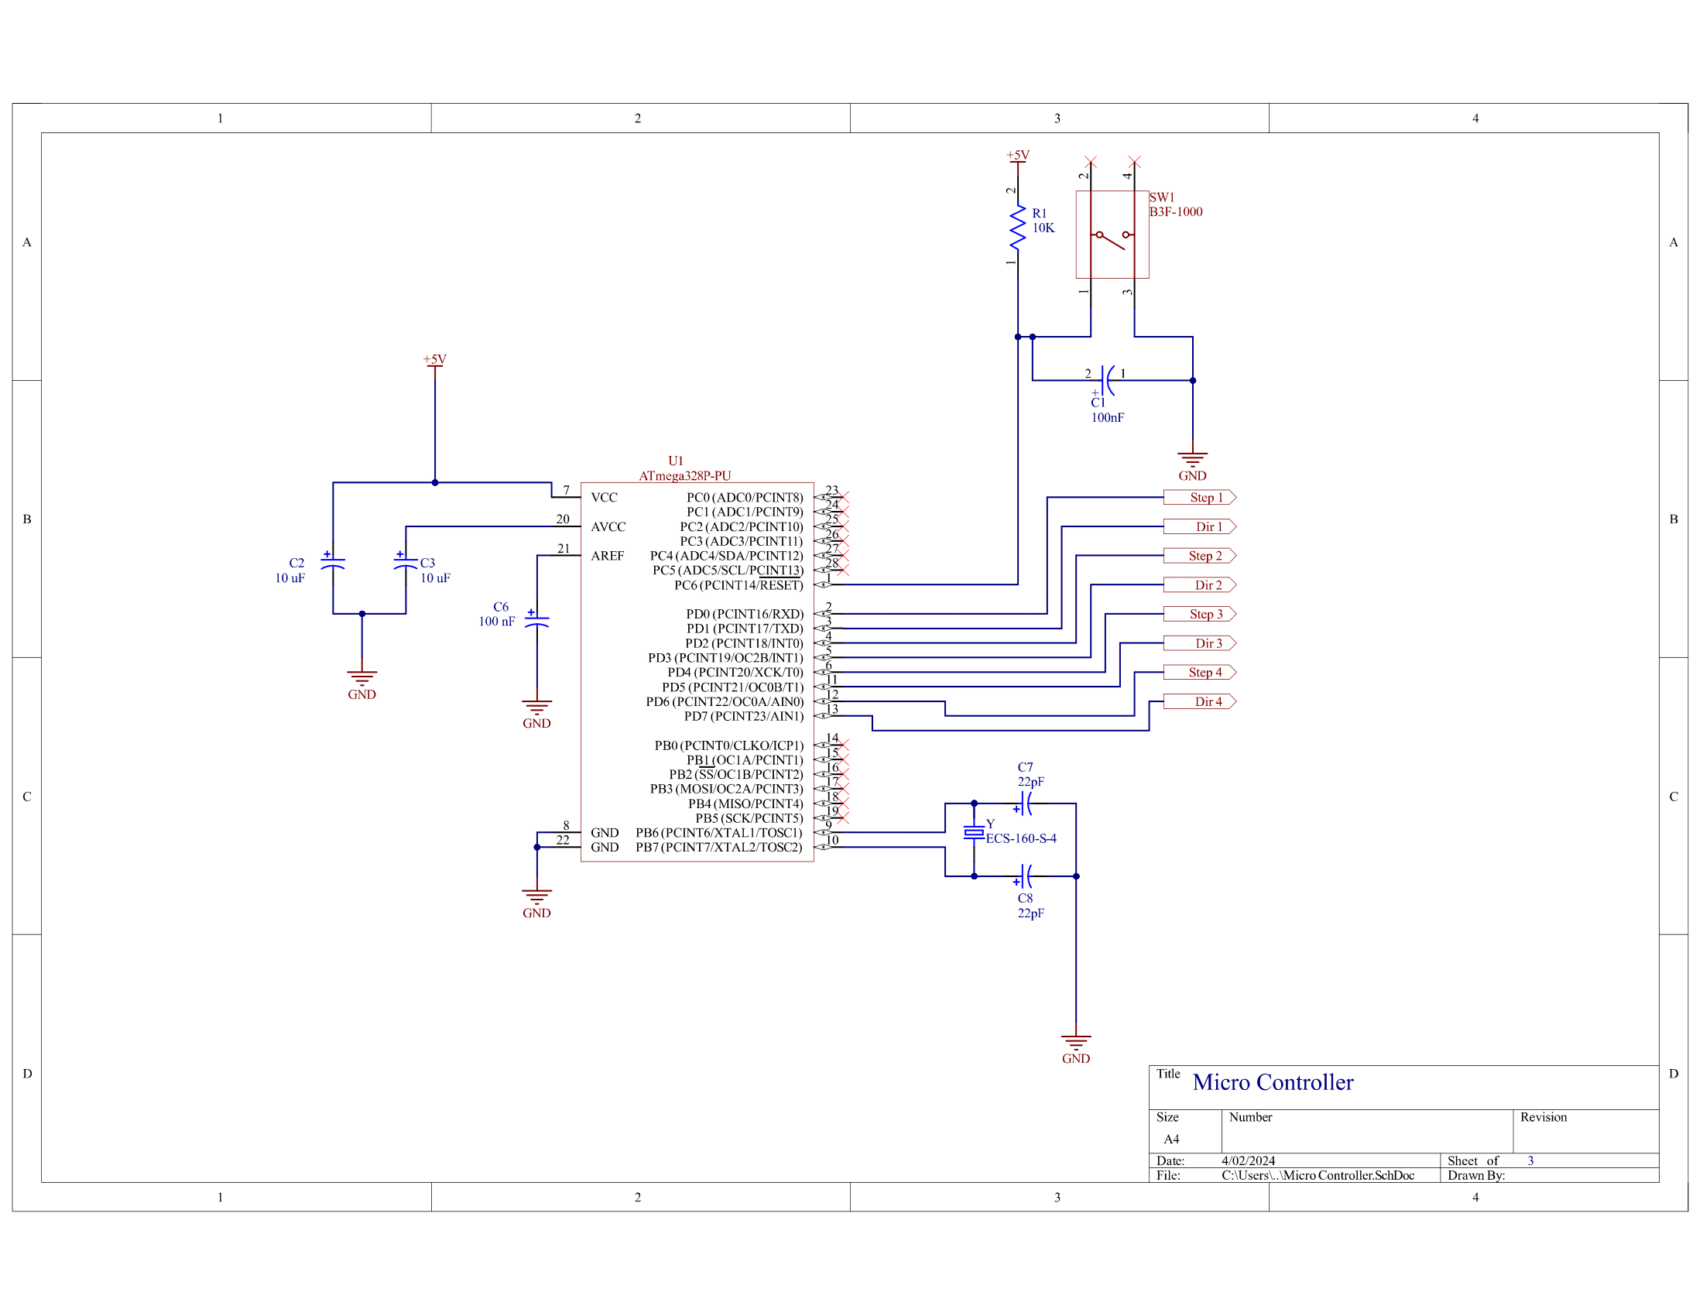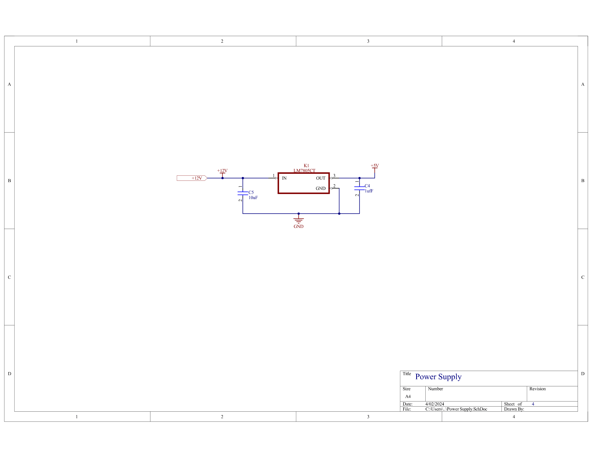

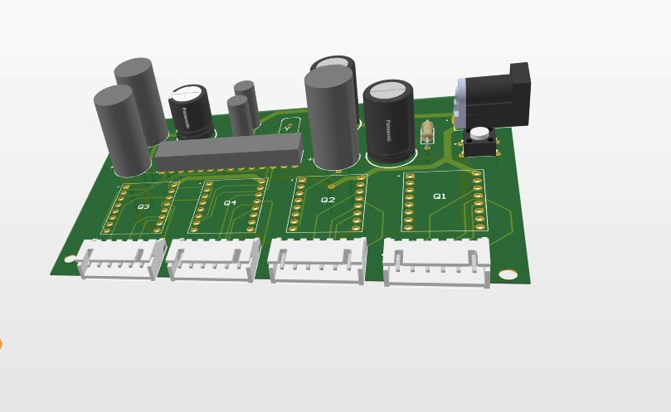**PCB Design**

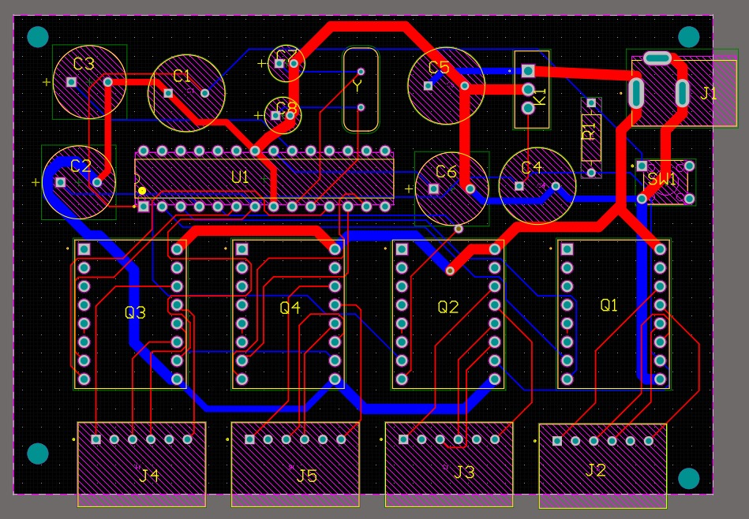

# **References**

1. P. Zhou et al., "Automated Assembly of Power Electronics Modules Using a Pick-and-Place Robot," in *Proceedings of the IEEE International Conference on Robotics and Automation*, 2018.
2. S.M.A. Hashmi et al., "Design and Development of a Flexible Pick-and-Place Robot for Electronics Assembly," in *Proceedings of the IEEE/RSJ International Conference on Intelligent Robots and Systems*, 2015.
3. Y. Liu et al., "Automated Assembly of High-Density TRANSISTOR Arrays for Motor Drives," in *IEEE Transactions on Industrial Electronics*, vol. 67, no. 9, pp. 7205-7213, 2020.
4. IEEE Xplore, "A Novel Automated Assembly System for High-Power TRANSISTOR Modules," IEEE, [Online]. Available: [Insert Link if Applicable]. Accessed on: [Insert Access Date].
5. Universal Robots, "Case Study: Automated Assembly of Brushless DC Motor Drives," in *IEEE/RSJ International Conference on Intelligent Robots and Systems (IROS)*, 2012.